How is energy transferred?

Energy can be transferred mechanically, electrically or by heating.

 | 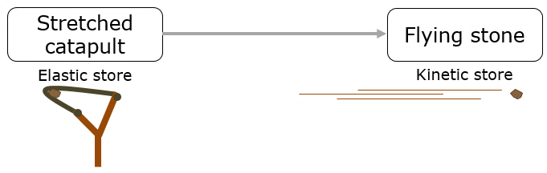  How is energy transferred by a catapult? | A Mechanically  B Electrically  C By heating
 | 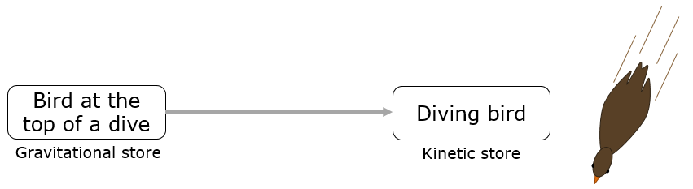  How is energy transferred when a bird dives? | A Mechanically  B Electrically  C By heating
 | 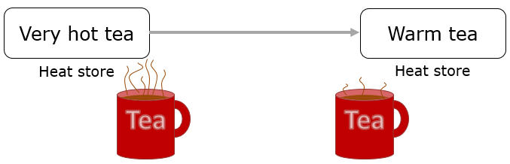  How is energy transferred from a very hot cup of tea? | A Mechanically  B Electrically  C By heating
 | How is energy transferred when a fan is switched on:  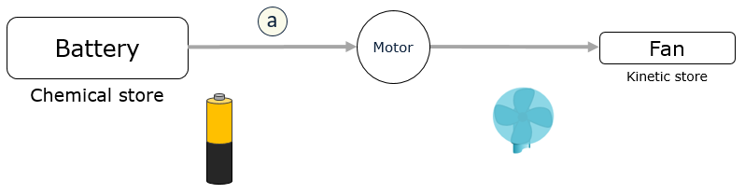  - to make the motor turn? | A Mechanically  B Electrically  C By heating
 | 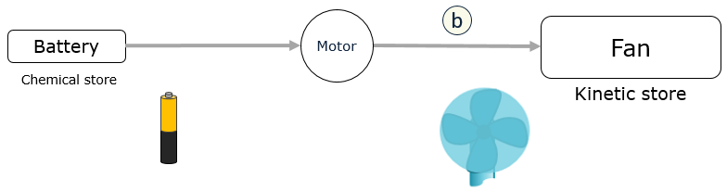  - to make the fan turn? | A Mechanically  B Electrically  C By heating

Physics > Big idea PFM: Forces and motion > Topic PFM1: Forces > Key concept PFM1.5: Energy stores and transfers
Diagnostic question
How is energy transferred?

Overview
Learning focus: | When a force makes things change it mechanically transfers energy between different energy stores.  Friction transfers energy mechanically into a heat store of energy.
Observable learning outcome: | - Identify different ways that energy can be transferred
Question type: | Diagnostic, simple multiple choice
Key words: | Energy transfer, mechanically, electrically, heating,  energy store chemical, elastic, gravitational, heat, kinetic

What does the research say?
In teaching energy the BEST resources have adopted a framework based on ‘energy stores’ and ‘energy pathways’ which is advocated by, amongst others, (Boohan, 2014), (Millar, 2014) and (Tracy, 2014). As Millar (2014) says, this approach “is not perfect - but it is adequate and significantly better than [approaches] based on lists of ‘forms of energy’.” A clear guide to this approach can be found on the Institute of Physics’ website (Institute of Physics).
Rogers (2018) highlights that the precision in the language we use about energy is important. Because energy is an abstract concept we have to use words to describe it. He advises giving students opportunities to practise using language precisely to help them develop an accurate model of what is happening. This question focuses on identifying how energy transferred. The Institute of Physics identify four ways that energy can be transferred: mechanically, electrically, heating by [moving] particles and heating by radiation. It is, however, more important to describe the mechanisms or processes that transfer energy, than it is to give each transfer a label.
When explaining how energy is transferred, Tracy (2014) recommends that we focus on describing the processes and mechanisms involved. He suggests that trying to identify the ‘energy’ in each step is just a labelling exercise that can get in the way of a clear understanding of what is happening.
A summary of the BEST approach to teaching energy can be found on the Best Evidence Science Teaching home page which is on the STEM Learning website (Fairhurst, 2018).
Ways to use this question
Students should complete the question individually. This could be a pencil and paper exercise, or you could use an electronic ‘voting system’ or mini white boards and the PowerPoint presentation.
The answers to the question will show you whether students understood the concept sufficiently well to apply it correctly.
If there is a range of answers, you may choose to respond through structured class discussion. Ask one student to explain why they gave the answer they did; ask another student to explain why they agree with them; ask another to explain why they disagree, and so on. This sort of discussion gives students the opportunity to explore their thinking and for you to really understand their learning needs.
Differentiation
You may choose to read the questions to the class, so that everyone can focus on the science. In some situations it may be more appropriate for a teaching assistant to read for one or two students.
Expected answers
1. Mechanically, 2. Mechanically, 3. By heating, 4a. Electrically, 4b. Mechanically
How to respond - what next?
- When the stone is let go the stretched elastic springs back to shape. It pushes the stone with a forwards force that accelerates the stone until it leaves the catapult.
- When the bird begins to dive there is an unbalanced force acting on it. The force is downwards, so the bird accelerates towards the ground. It keeps accelerating and will be at its fastest just before it hits the water.
- The very hot tea contains fast moving particles. These bash into the particles of the air and make them move more quickly. The particles in the tea move more slowly so the tea’s temperature goes down.
- Chemicals in the battery react in a way that pushes electricity through the wires. The moving electricity pushes the motor round. The blades of the fan are connected to the motor, so that when the motor turns the blades spin as well.
If students have difficulty in describing each type of energy transfer, it can help to focus discussion on what is actually happening to transfer the energy from one place to another. Giving students further examples to discuss in pairs or in small groups can encourage more complete descriptions and understanding through dialogue.
The following BEST ‘response activity’ could be used in follow-up to this diagnostic question:
- Response activity: Transferring energy
Acknowledgments
Developed by Peter Fairhurst (UYSEG).
Images: UYSEG
References

